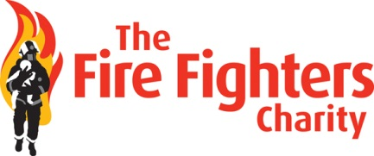
Media Pack

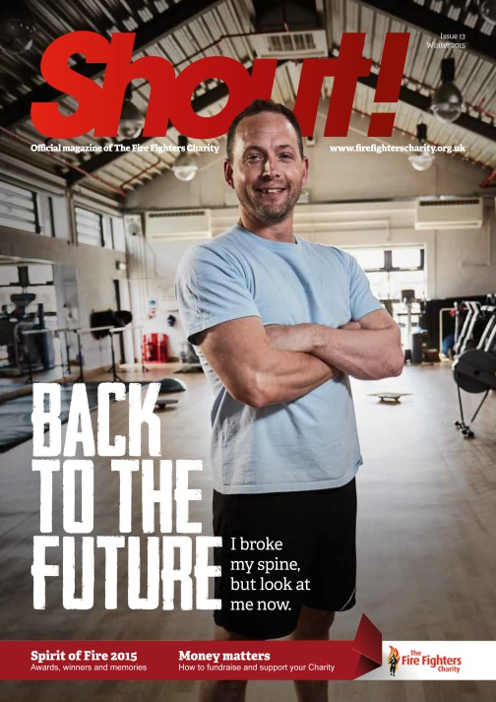
About Shout!

Pagination: 44pp
Paper weight: Covers 150gsm gloss; text 80gsm gloss
Publication: Twice yearly
Detail: Shout! is the official magazine of The Fire Fighters Charity. An energetic, informative and universally well received title, it features a wealth of information on the Charity, its beneficiaries, supporters and services. However, far more than just a charity magazine seeking to boost fundraising income, Shout! offers its readers practical advice on health and wellbeing throughout, echoing the Charity’s mission to enhance the lives of firefighters across the country.
Redesign: Shout! was redesigned in April 2015, giving it a strong consumer-title look and feel

About Our Readers

Circulation: 29,201
Gender: 78.5% Male
Age range: 25-50
Estimated readership: 122,603 per issue (average 3 people per household, 15 people per fire station and 5 people per HQ)
Occupations: Serving wholetime firefighters, serving retained firefighters, retired firefighters

About The Charity

The Fire Fighters Charity is the UK’s leading provider of rehabilitation and recuperation services to the fire community. In 2015/16 it helped 5,107 people across its three centres in the Lake District, Devon and West Susssex, helping them to recover from injury and illness through life enhancing rehabilitation, as well as other health and wellbeing services – including psychological therapy – facilitated by dedicated teams of clinical professionals. The Charity receives no regular Government funding and is financed through the generosity of its supporters. Full details of the Charity’s beneficiaries, services and finances can be found via its 2015/16 Impact Report, available at: https://issuu.com/thefirefighterscharity/docs/1854_ffc_impact_report_2015_16_web

Opportunities
There are a number of opportunities available to advertisers and sponsors in Shout! magazine, at rates well below those of other titles in the sector.

Advertising rate card

Commitment | 0.5 page | 1p | Back cover | Inside back cover | Inside front cover
1 issue | 800 | 1500 | 2000 | 1750 | BOOKED
2 issues (-10%) | 1440 | 2700 | 3600 | 3150 | BOOKED

Section sponsorship

The following sections of Shout magazine are available for sponsorship

Section | No. of pages | Subject matter | Sponsorship opportunity | Per issue cost
@FFC | 1 | Social media updates fron Twitter and Facebook | Logo placement and ‘sponsored by’ recognition | £500
Firefighting Fit | 5 | Health and wellbeing. Columns from exercise therapists, psychological therapists, nutrition experts etc. offering advice and guidance on physical and mental wellbeing. | Logo placement on all pages. ‘Sponsored by recognition on all pages.’  Single page advertorial. | £1500
Shout+ | 4 | Focus on the retired fire and rescue community. Offering information and insight to retired readers, helping them to keep in touch with past colleagues etc. | Logo placement on all pages. ‘Sponsored by recognition on all pages.’  Single page advertorial. | £1250

For more information

Email: Shout@firefighterscharity.org.uk
Telephone: 01256 366591

